**LF RFID Foot Ring Tag**

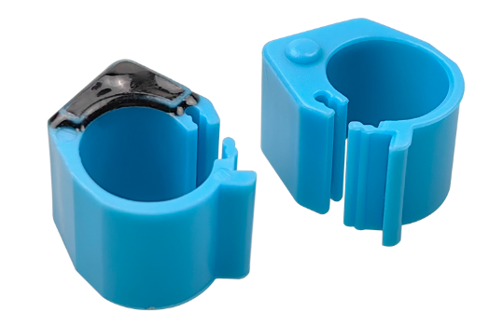

**Quick Details**

LDI-F02 LF RFID foot ring tag good quality material. It is designed for poultry management which is effective to keep tracking of poultry, such as bird, chicken and pigeon. Identification/tracing of poultry products, prevention and control of animal epidemics, intelligent poultry farming, information management and tracking of poultry.

**Description**

|  |  |  |  |
| --- | --- | --- | --- |
| **RFID Parameter** | | | |
| Model No. | LDI-F02 | | |
| Type | Passive LF RFID Pigeon Tag | | |
| Protocol | ISO18000-2 | ISO11785/85 | ISO11785/85 |
| Frequency | 125Khz | 134.2KHz | 125KHz |
| Chip | Hitags256 | | |
| Read | Supported | | |
| Data retention | 5 years | | |
| **Physical Parameter** | | | |
| Color | Blue, other color customized | | |
| Size | Tag: 13.6*12*10mm (L×W)，Inner diameter 8mm | | |
| Surface Material | PE | | |
| Operating temperature | -10℃ ~ +55℃ | | |
| Storage temperature | -20℃~+65℃ | | |
| Weight | 1.3g | | |
| Package | 100sets/bag,10bags/carton | | |
| Customized Service | Laser printing, Color | | |

**Application**

* Poultry identification
* Birds, chicken and pigeon tracking
* Intelligent management